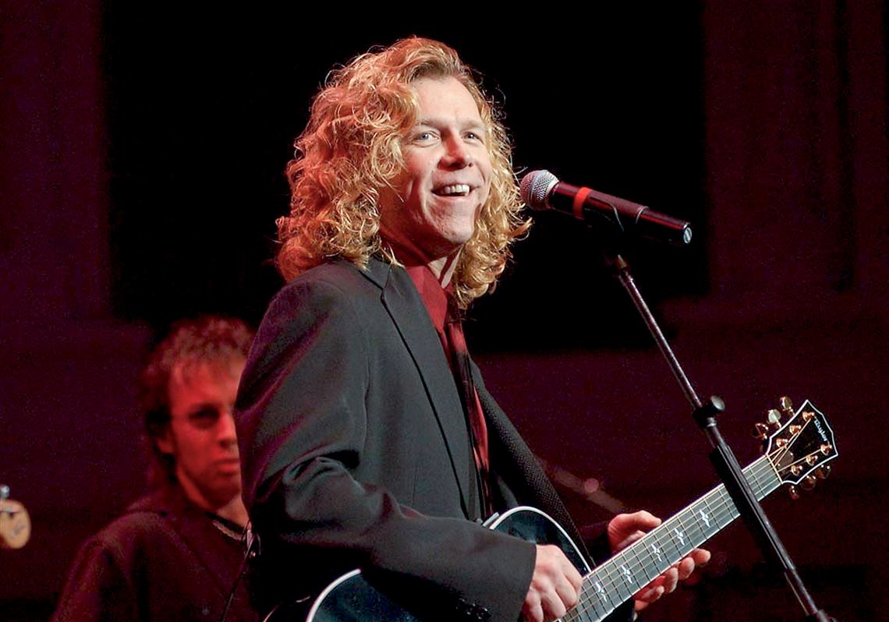

First Person: The life lessons of B.E.Taylor
He came to little Elkins, W.Va., 30 years, and showed me the meaning of respect, hard work and dignity

CRAIG IRONS

AUG 13, 2016

Pittsburgh lost a local legend when B.E. Taylor passed away this week at 65. The news saddened many people who had seen him perform and whose lives he had touched.
I never crossed paths with Mr. Taylor or saw one of his popular Christmas shows, but I’ll never forget a night more than 30 years ago when he taught me an important life lesson.
In the mid-1980s, I was an impressionable teenager growing up in Elkins, W.Va., three hours south and a world away from Pittsburgh, which then, as now, was the nearest “big city.” From afar, those of us in Elkins watched Steelers and Pirates games on Pittsburgh TV stations and could listen to Pittsburgh radio stations through our local cable system.
It was on WDVE that we heard B.E. Taylor’s hit “Vitamin L” in rotation with The Police, Styx, Bad Company, Bob Seeger and Led Zeppelin. It was a good song, and even though we knew it was by a local Pittsburgh artist, it sounded as professional as the recordings by those bigger acts.
At some point, the exciting news was announced that B.E. Taylor was to perform in Elkins. This was unheard of. Other than country acts that performed at the Mountain State Forest Festival each October, nobody, it seemed, ever came to play in Elkins.
My best friend and I were ecstatic and we schemed to show up early to the Elkins National Guard Armory. We fretted that the show would sell out, so we arrived as soon as the doors opened. But a curious thing happened that I still can’t understand. We hadn’t beaten the crowd — there was no crowd to beat. There were only about 20 people in the cavernous venue.
The opening act, a local band I hadn’t seen before and never saw again, started playing. For some reason, the drummer was wearing a karate robe and flip-flops and, at one point, as the guitarist reeled off an interminable guitar solo, he strutted around the perimeter of the basketball court drumming the air in time.
The bands’ disappointment at the poor turnout was palpable. They performed with an air of self-consciousness that extinguished what little bit of energy there was in the big, echoing gym. When they’d finished, a couple of them retreated to bleachers to sit, disillusioned, with their girlfriends, who were ready with hugs and encouragement. It was hard not to feel sorry for them.
As the opening act’s equipment was being packed away, I remember telling my friend that I had no idea what to expect from B.E. Taylor. He and his band had come all the way down from Pittsburgh and would be playing to only 20 people? Not for the first or last time, I was embarrassed by my hometown.
I needn’t have worried. When B.E Taylor and his band hit the stage, with their big sound and colorful lights, there was no question that the show would go on. What’s more, as the music started and B.E. walked onto the stage smiling and saw the paltry number of people who had come to watch him perform, he didn’t let on for a second that he was disappointed.
As the first song started, he warmly threw out his arms and invited everyone to come right up in front of the stage. “Everywhere we go,” I remember him saying, “we always like to make new friends.”
Unlike the opening act, he didn’t focus on those who had stayed home. He turned his energy entirely to those of us who were there.
The rest of the evening was a treat of the first order. B.E. and his band put on a fantastic show. His voice was in fine form, the songs were great, and his band was just as committed as he was to making the evening memorable for the 20 people congregated in one end of a gym in Elkins, W.Va.
You never know what moments will help shape you, but I know now that that evening was one of them for me. B.E. Taylor taught me what it meant to be a professional, though it would take time and maturity for me to fully grasp the lesson.
He left behind a valuable memory — an exemplary model of behavior and showmanship. And words to live by.
Everywhere I go, I try to make new friends.
Craig Irons is a writer and marketing manager living in Mt. Lebanon.

